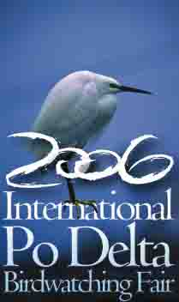
3° BIRDWATCHING AND NATURE TOURISM FAIR, COMACCHIO, April 28th –May 1 st 2006

DELTA 2000, Province of Ravenna, Inter Municipality Association of Southern Emilia Romagna, Municipality of Ravenna- S. Alberto district, in collaboration with the local associations and with the bike guides Lugo
organise the 2° edition

Cycling in the Po Delta Park

Alfonsine- S.Alberto- Comacchio

Sunday April 30th 2006 9 am-6.30 pm

Programme
9,00 departure from Alfonsine piazza Gramsci in front of the town hall
9,30 departure from the ferry boat area S.Alberto at the end of via Nigrisoli
10,00 meeting of the two cycling groups Noth of Anita in via Rotta Martinella, then along Agosta riverbank towards Comacchio
10,30-11,15 break in valle Zavelea and introduction to birdwatching with the experts from
Ardeola association

MEETING WITH THE19° CICLODELTA DELLA LIBERTA’
ORGANISED BY ’A.N.P.I’.,COMACCHIO

12,00 arrival in Comacchio, lunch and visit to the Birdwatching Fair pavilions
15,00 pm meeting at the courtyard of Palazzo Bellini and departure to get back, with a brief stop half the way.

Route lenght to go and back: from Alfonsine km.66, from S.Alberto km.62.
Remember to take the binoculars with you. It is possible to rent bikes by the Palazzone, S.Alberto.
All the participants will be given a Bird Card (valid from April 28th 2006 to March 31st 2007), a facility card allowing to participate in all the Fair events for free (excursions,environmental education labs , lectures, photography and birdwatching lessons, theoretical and/or in the field, etc…)and also to discounts and advantageous prices in shops and tourist facilities in agreement with the Fair.

In event of bad weather, , lthe cycling tour will take place the following day Monday May 1st with the same programme.

Organising Committee: for information please call “Ciclo Guide Lugo” 0545-58328, or” Casa Monti-Alfonsine” 0544-869808, or “ Visitor Center -Palazzone di S.Alberto” 0544-

